**Assignment 4: Mitesh Sharma**

**___________________________________________________**

SET UP THE REPOSITORY

* Update the apt package index:

$ sudo apt-get update

* Install packages to allow apt to use a repository over HTTPS:

$ sudo apt-get install \

apt-transport-https \

ca-certificates \

curl \

software-properties-common

*Add Docker’s official GPG key:

$ curl -fsSL https://download.docker.com/linux/ubuntu/gpg | sudo apt-key add -

*Verify that the key fingerprint is:

9DC8 5822 9FC7 DD38 854A E2D8 8D81 803C 0EBF CD88

sudo apt-key fingerprint 0EBFCD88

pub 4096R/0EBFCD88 2017-02-22

Key fingerprint = 9DC8 5822 9FC7 DD38 854A E2D8 8D81 803C 0EBF CD88

uid Docker Release (CE deb) <docker@docker.com>

sub 4096R/F273FCD8 2017-02-22

Use the following command to set up the stable repository:

$ sudo add-apt-repository \

“deb [arch=amd64] https://download.docker.com/linux/ubuntu \

$(lsb_release -cs) \

Stable”

* Update the apt package index.

$ sudo apt-get update

 * Install the latest version of Docker CE:

$ sudo apt-get install docker-ce

*Verify that Docker CE is installed correctly by running the hello-world image.

$ sudo docker run hello-world

**______________________________________________________**

sudo yum update

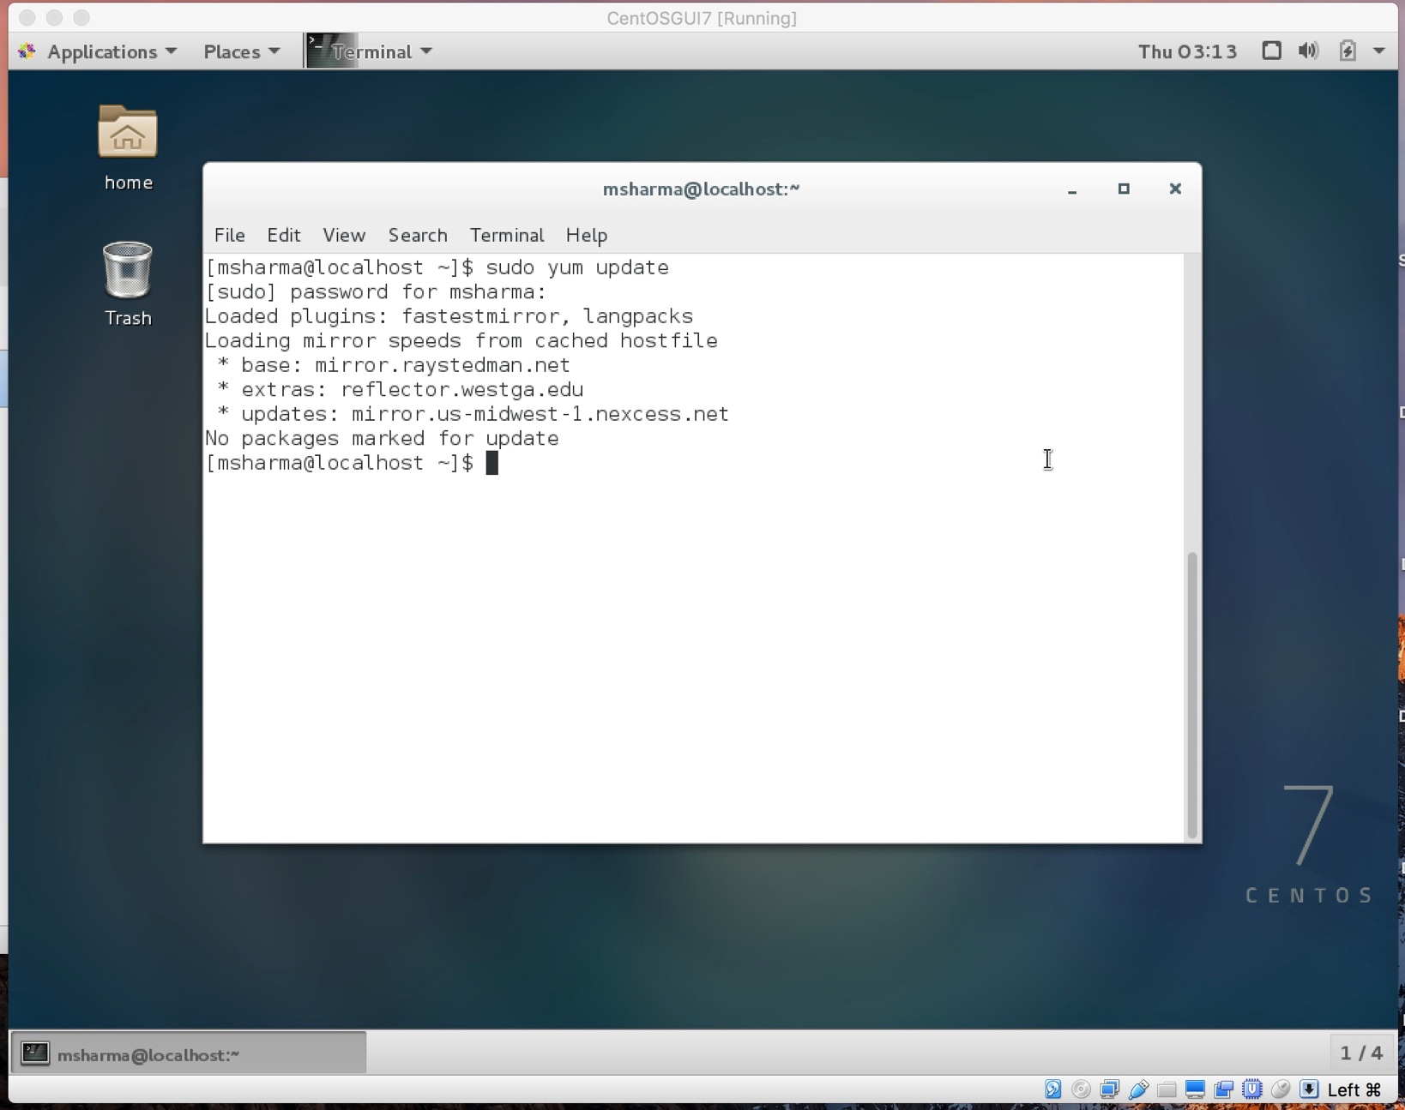

install docker

curl -fsSL <https://get.docker.com/> | sh

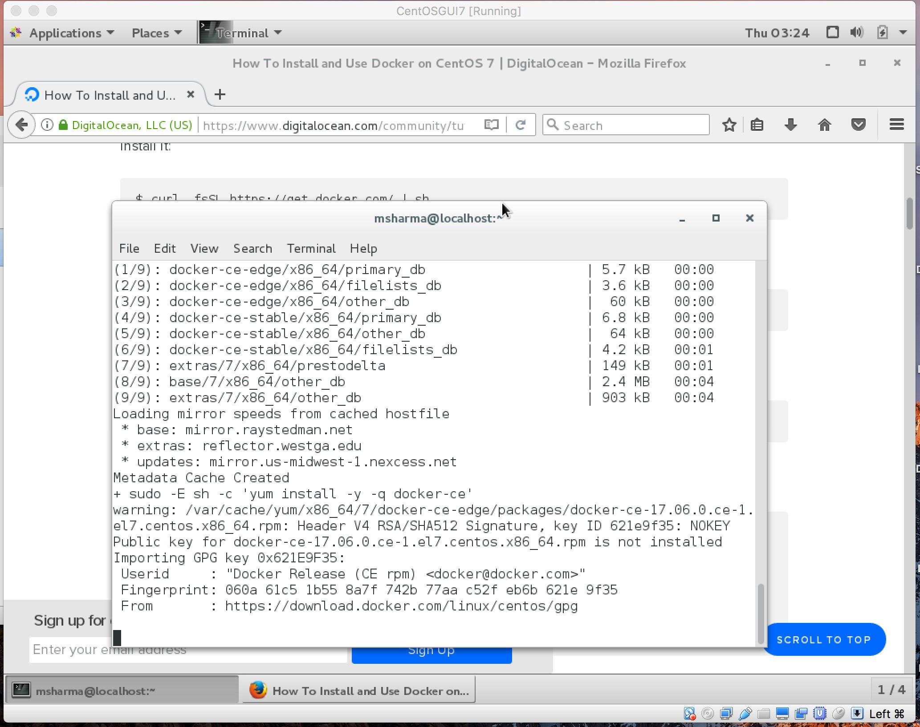

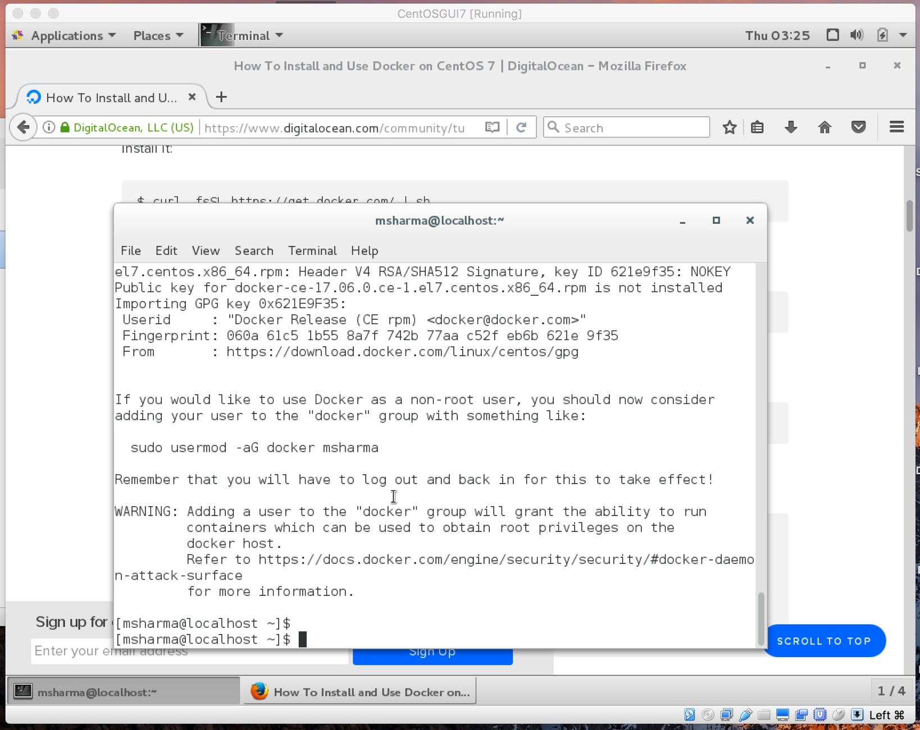

sudo systemctl start docker

sudo systemctl status docker

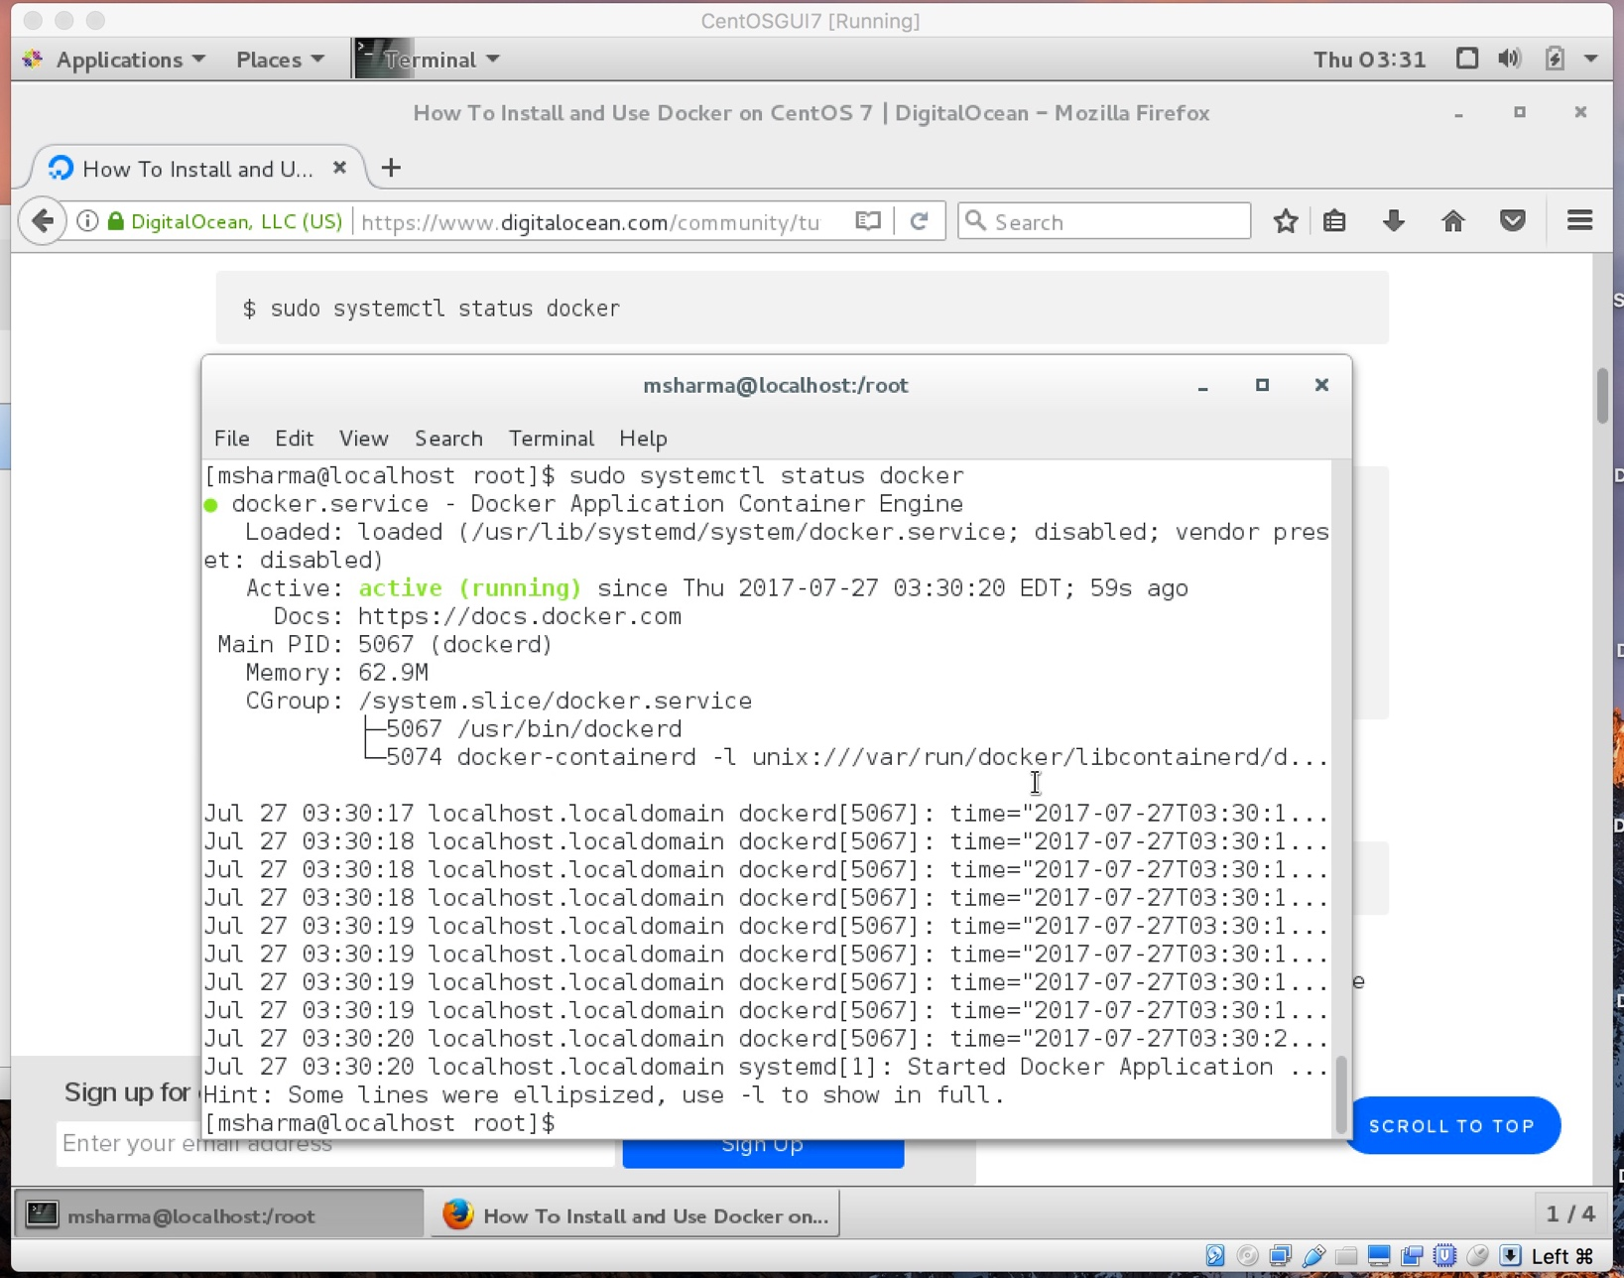

docker run hello-world

